***Solution*** ***Section* 2.2 – Trigonometric Integrals**

***Exercise***

Evaluate the integral 

***Solution***















***Exercise***

Evaluate 

***Solution***

 

 





***Exercise***

Evaluate 

***Solution***

|  |  |  |
| --- | --- | --- |
|  |  |  |
| **+** |  |  |
| **−** |  |  |
| **+** |  |  |







***Exercise***

Evaluate 

***Solution***

  







***Exercise***

Evaluate the integral 

***Solution***









***Exercise***

Evaluate the integral 

***Solution***

 

















***Exercise***

Evaluate the integral 

***Solution***



 



 













***Exercise***

Evaluate the integral 

***Solution***

 









***Exercise***

Evaluate the integral 

***Solution***

 











***Exercise***

Evaluate 

***Solution***

 



***Exercise***

Evaluate 

***Solution***







***Exercise***

Evaluate the integral 

***Solution***

 



***Exercise***

Evaluate the integral 

***Solution***













***Exercise***

Evaluate 

***Solution***







***Exercise***

Evaluate the integral 

***Solution***











***Exercise***

Evaluate 

***Solution***













***Exercise***

Evaluate the integral 

***Solution***











***Exercise***

Evaluate the integral 

***Solution***









***Exercise***

Evaluate the integral 

***Solution***



















***Exercise***

Evaluate the integral 

***Solution***



















***Exercise***

Evaluate 

***Solution***













***Exercise***

Evaluate the integral 

***Solution***











***Exercise***

Evaluate the integral 

***Solution***











***Exercise***

Evaluate the integral 

***Solution***











***Exercise***

Evaluate the integral 

***Solution***













***Exercise***

Evaluate the integral 

***Solution***









***Exercise***

Evaluate the integral 

***Solution***















***Exercise***

Evaluate the integral 

***Solution***













***Exercise***

Evaluate the integral 

***Solution***









***Exercise***

Evaluate the integral 

***Solution***











***Exercise***

Evaluate the integral 

***Solution***









***Exercise***

Evaluate the integral 

***Solution***











***Exercise***

Evaluate the integral 

***Solution***















***Exercise***

Evaluate the integral 

***Solution***

***Exercise***

Evaluate 

***Solution***















***Exercise***

Evaluate the integral 

***Solution***







***Exercise***

Evaluate the integral 

***Solution***





















***Exercise***

Evaluate the integral 

***Solution***











***Exercise***

Evaluate the integral 

***Solution***











***Exercise***

Evaluate the integral 

***Solution***













***Exercise***

Evaluate the integral 

***Solution***





***Exercise***

Evaluate the integral 

***Solution***









***Exercise***

Evaluate the integral 

***Solution***

 









***Exercise***

Evaluate the integral 

***Solution***

 















***Exercise***

Evaluate the integral 

***Solution***

 







***Exercise***

Evaluate the integral 

***Solution***

 





 





***Exercise***

Evaluate the integral 

***Solution***

 

 



***Exercise***

Evaluate the integral 

***Solution***









***Exercise***

Evaluate the integral 

***Solution***









***Exercise***

Evaluate the integral 

***Solution***

















***Exercise***

Evaluate the integral 

***Solution***

 







***Exercise***

Evaluate the integral 

***Solution***

 







***Exercise***

Evaluate the integral 

***Solution***

 





***Exercise***

Evaluate the integral 

***Solution***

 







***Exercise***

Evaluate the integral 

***Solution***

 





***Exercise***

Evaluate the integral 

***Solution***

 







***Exercise***

Evaluate the integral 

***Solution***



 





***Exercise***

Evaluate the integral 

***Solution***

 







***Exercise***

Evaluate the integral 

***Solution***

 





***Exercise***

Evaluate the integral 

***Solution***





***Exercise***

Evaluate the integral 

***Solution***





***Exercise***

Evaluate the integral 

***Solution***









***Exercise***

Evaluate 

***Solution***

 







***Exercise***

Evaluate the integral 

***Solution***









***Exercise***

Evaluate the integral 

***Solution***









***Exercise***

Evaluate the integral 

***Solution***











































***Exercise***

Evaluate the integral 

***Solution***

 













***Exercise***

Evaluate the integral 

***Solution***









***Exercise***

Evaluate the integral 

***Solution***









***Exercise***

Evaluate the integral 

***Solution***







***Exercise***

Evaluate the integral 

***Solution***















***Exercise***

Evaluate the integral 

***Solution***















***Exercise***

Evaluate the integral 

***Solution***











***Exercise***

Evaluate the integral 

***Solution***









***Exercise***

Evaluate the integral 

***Solution***



















***Exercise***

Evaluate the integral 

***Solution***

 



***Exercise***

Evaluate the integral 

***Solution***

 







***Exercise***

Evaluate the integral 

***Solution***







***Exercise***

Evaluate the integral 

***Solution***







***Exercise***

Evaluate the integral 

***Solution***











***Exercise***

Evaluate the integral 

***Solution***











***Exercise***

Evaluate the integral 

***Solution***











***Exercise***

Evaluate 

***Solution***

 

 



***Exercise***

Evaluate the integral 

***Solution***









***Exercise***

Evaluate the integral 

***Solution***











***Exercise***

Evaluate the integral 

***Solution***











***Exercise***

Evaluate the integral 

***Solution***











***Exercise***

Evaluate 

***Solution***





***Exercise***

Evaluate the integral 

***Solution***















***Exercise***

Evaluate the integral 

***Solution***







***Exercise***

Evaluate the integral 

***Solution***













***Exercise***

Evaluate the integral 

***Solution***





***Exercise***

Evaluate the integral 

***Solution***





***Exercise***

Evaluate the integral 

***Solution***











***Exercise***

Evaluate the integral 

***Solution***











***Exercise***

Evaluate the integral 

***Solution***









***Exercise***

Evaluate the integral 

***Solution***







***Exercise***

Evaluate the integral 

***Solution***

 







***Exercise***

Evaluate the integral 

***Solution***













***Exercise***

Evaluate the integral 

***Solution***











***Exercise***

Evaluate the integral 

***Solution***





***Exercise***

Evaluate the integral 

***Solution***











***Exercise***

Evaluate the integral 

***Solution***











***Exercise***

Evaluate the integral 

***Solution***











***Exercise***

Evaluate the integral 

***Solution***









 









***Exercise***

Evaluate the integral 

***Solution***













***Exercise***

Evaluate the integral 

***Solution***















***Exercise***

Evaluate the integral 

***Solution***













***Exercise***

Evaluate the integral 

***Solution***













***Exercise***

Evaluate the integral 

***Solution***



















***Exercise***

Evaluate the integral 

***Solution***







***Exercise***

Evaluate the integral 

***Solution***

















***Exercise***

Evaluate the integral 

***Solution***















***Exercise***

Evaluate the integral 

***Solution***

















***Exercise***

Evaluate the integral 

***Solution***















***Exercise***

Evaluate the integral 

***Solution***

 











***Exercise***

Evaluate the integral 

***Solution***

 







***Exercise***

Evaluate the integral 

***Solution***









***Exercise***

Evaluate the integral 

***Solution***



 

 















***Exercise***

Evaluate the integral 

***Solution***













***Exercise***

Evaluate the integral 

***Solution***

















***Exercise***

Evaluate the integral 

***Solution***





 

 













***Exercise***

Evaluate the integral 

***Solution***





 

 













***Exercise***

Evaluate the integral 

***Solution***

 

 











***Exercise***

Evaluate the integral 

***Solution***

 











***Exercise***

Evaluate the integral 

***Solution***

 









***Exercise***

Evaluate the integral 

***Solution***



















***Exercise***

Evaluate the integral 

***Solution***



















***Exercise***

Evaluate the integral 

***Solution***









***Exercise***

Evaluate the integral 

***Solution***











***Exercise***

Evaluate the integral 

***Solution***











***Exercise***

Evaluate the integral 

***Solution***









***Exercise***

Evaluate the integral 

***Solution***

 













***Exercise***

Evaluate the integral 

***Solution***













***Exercise***

Evaluate the integral 

***Solution***







***Exercise***

Evaluate the integral 

***Solution***





















***Exercise***

Evaluate the integral 

***Solution***

 



***Exercise***

Evaluate 

***Solution***























***Or***

 



***Exercise***

Evaluate 

***Solution***

 



***Or***













***Exercise***

Evaluate 

***Solution***

 



***Or***











***Exercise***

Evaluate 

***Solution***

 



***Or***











***Exercise***

Evaluate the integral 

***Solution***

 



***Exercise***

Evaluate the integral 

***Solution***

 



***Exercise***

Evaluate the integral 

***Solution***









***Exercise***

Find the area of the region bounded by the graphs of  and  on the interval 

***Solution***











***Exercise***

Find the area of the region bounded by the graphs of the equations 

***Solution***

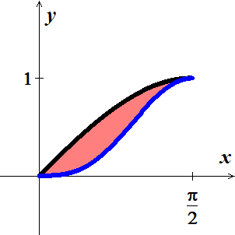









***Exercise***

Find the area of the region bounded by the graphs of the equations 

***Solution***

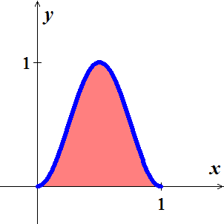







***Exercise***

Find the area of the region bounded by the graphs of the equations 

***Solution***

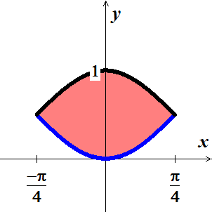









***Exercise***

Find the area of the region bounded by the graphs of the equations



***Solution***

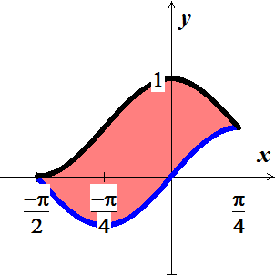











***Exercise***

Find the volume of the solid generated by revolving the region bounded by the graphs of the equations about the  

***Solution***

***Disks*** Method:

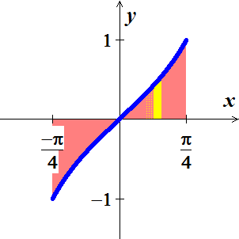









***Exercise***

Find the volume of the solid generated by revolving the region bounded by the graphs of the equations about the  

***Solution***

 

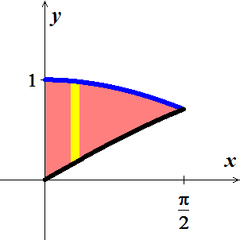 





***Exercise***

Find the ***volume*** of the solid generated by revolving the region bounded by the graphs of the equations about the , then find the ***centroid*** of the region



***Solution***

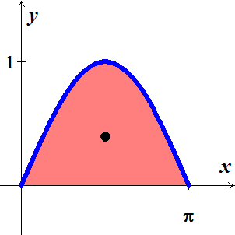















|  |  |  |
| --- | --- | --- |
|  |  |  |
| **+** |  |  |
| **−** | 1 |  |

















***Exercise***

Find the ***volume*** of the solid generated by revolving the region bounded by the graphs of the equations about the , then find the ***centroid*** of the region

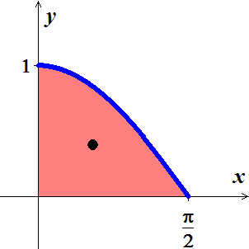 

***Solution***















|  |  |  |
| --- | --- | --- |
|  |  |  |
| **+** |  |  |
| **−** | 1 |  |















